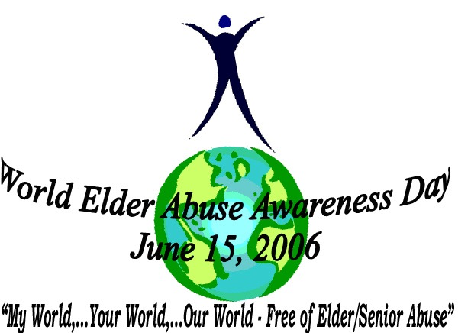
You are cordially invited to attend

A Global

Celebration and Launch
of the first

World Elder Abuse Awareness Day

Thursday, June 15, 2006

1:30 p.m. to 4:30 p.m.

at the

United Nations Headquarters

New York City
Conference Room 2

RSVP by June 5, 2006
Via: e-mail to weaad-info@inpea.net
Via: Fax/Phone +1 (212) 795-7713
Or Mail to: 780 Third Avenue, 30th Floor
New York, NY 10017 USA
Registration is required for this event in order to obtain United Nations Security Clearance.
Therefore, kindly submit your registration as soon as possible.
On Thursday, June 15, plan to arrive early to allow time for security screening.

Please bring photo ID to UN Visitors Entrance located at First Ave. and 45th Street, NYC
…and your copy of this invitation.
REGISTRATION
World Elder Abuse Awareness Day - Thursday, June 15, 2006 – UNHQ - 1:30 p.m. to 4:30 p.m.
Please Print or Type:
First Name: MI: Last Name:
Title: Affiliation:
Telephone: FAX:
e-mail:
Address:

City: State/Prov: Postal Code:
Country:
I have a United Nations Ground Pass
I am willing to volunteer on June 15 for WEAAD
Please retain a copy of this invitation as your confirmation of registration.
Fill in – Save to your computer then E-mail form to: weaad-info@inpea.net
or Mail to: 780 Third Avenue, 30th Floor, New York, NY 10017 USA
Fax/Phone: +1 (212) 795-7713
To see Preliminary Program please visit us at http://www.inpea.net

